|  |  |
| --- | --- |
| ***Are U Query-ous?* A Web-Based Platform for**  **Democratizing Open Geospatial Data Access**  *From Queries to Maps, A New Way to See the World!* | |
|  | |
|  | **TFG - Localization Based Systems and Intelligent Spaces**  Bachelor's degree in Techniques for Software Application Development  **Author:**  *Nicolas D’Alessandro Calderon*  **Project supervisor:**  *Joaquín Torres Sospedra*  **Coordinating professor:**  *Antoni Perez-Navarro* |

  
*This work is distributed under a*

*Creative Commons* [*Attribution-NonCommercial-NoDerivs*](https://creativecommons.org/licenses/by-nc-nd/3.0/) *3.0 license.*

**Abstract**

This study explores the challenge of making open data more accessible to the general public, addressing the gap between the availability of geospatial information and its practical use. *Are U Query-ous?* is a web-based application designed to enable individuals, regardless of their technical background, to explore and interpret geographic and demographic data intuitively. By integrating interactive maps and user-friendly visualization tools, the platform allows users to analyze regions based on economic activity, population distribution, and local trends.

Through a simplified interface, users can explore and filter publicly available data, identifying patterns relevant to their interests. The application is intended for individuals who are curious about urban development, seeking optimal locations for personal or professional activities, or analyzing demographic trends for research or decision-making. Additionally, the project examines the potential integration of artificial intelligence to facilitate data retrieval through natural language queries, further enhancing accessibility.

The development and results of the analyses in this data scientific report are intended to address all the concepts targeted in the foregoing. The author also expects to depict some fundamental principles underlying web apps development and data science.

**Keywords**

Geospatial Data, Open Data Visualization, Interactive Maps, Urban Analytics, Location Intelligence

Index

01 INTRODUCTION 1

1.1 Summary of the Proposal 1

1.2 Scope of the Project 2

1.2 Justification 3

1.3 Motivation 3

1.4 Objectives 4

1.4.1 Main Objective 4

1.4.2 Sub-Objectives 4

1.5 Hypothesis 5

1.6 Sustainability, diversity, and ethical/social challenges 5

1.6.1 Sustainability 5

1.6.2 Ethical behaviour and social responsibility 5

1.6.3 Diversity, gender and human rights 5

02 PLANNING 6

2.1 Project Planning 6

2.2 Expected Outcome 6

03 METHODS AND RESOURCES 7

3.1 Approach and Methodology 7

3.1.1 Data Collection and Processing 7

3.1.2 Backend Development 7

3.1.3 Frontend Development 7

3.1.4 Testing and Refinement 7

3.2 Technology 9

3.2.1 Frontend: 9

3.2.2 Backend: 9

3.2.3 Data Processing & Integration: 9

3.2.4 Deployment & Hosting: 9

3.2.5 Potential AI Integration (Optional): 9

04 RESULTS 11

05 CONCLUSIONS AND FUTURE WORK 12

06 GLOSSARY 13

07 BIBLIOGRAPHY 14

08 APPENDICES 15

**List of figures**

**01 INTRODUCTION**

Figure 1 1: Conceptual Representation of Project Summary 1

Figure 1 2: Key Motivations for the Project 3

Figure 1 3: Objectives Breakdown 4

**02 PLANNING**

Figure 2 1: Expected Outcome Visual Representation 6

**03 METHODS AND RESOURCES**

Figure 3 1: Process Diagram 8

Figure 3 2: Technology Stack Used 10

01  
 INTRODUCTION

1.1 Summary of the Proposal

This final project focuses on developing an intuitive **geo-analytics platform** that simplifies the exploration of open data through **interactive maps**. Many open data sources provide valuable insights into **urban planning, demographics, and economic activity**, but non-experts often struggle to extract meaningful information from them.

**Are U Query-ous**? aims to solve this problem by creating a **user-friendly interface** that enables individuals to explore and analyze spatial data without requiring technical expertise.

At the end of the project, the system will provide a **fully functional prototype** that allows users to:

* **Filter** and **visualize** location-based open data.
* Identify **regional patterns and trends** based on economic and demographic factors.
* Utilize **intelligent search capabilities** to access relevant insights more intuitively.

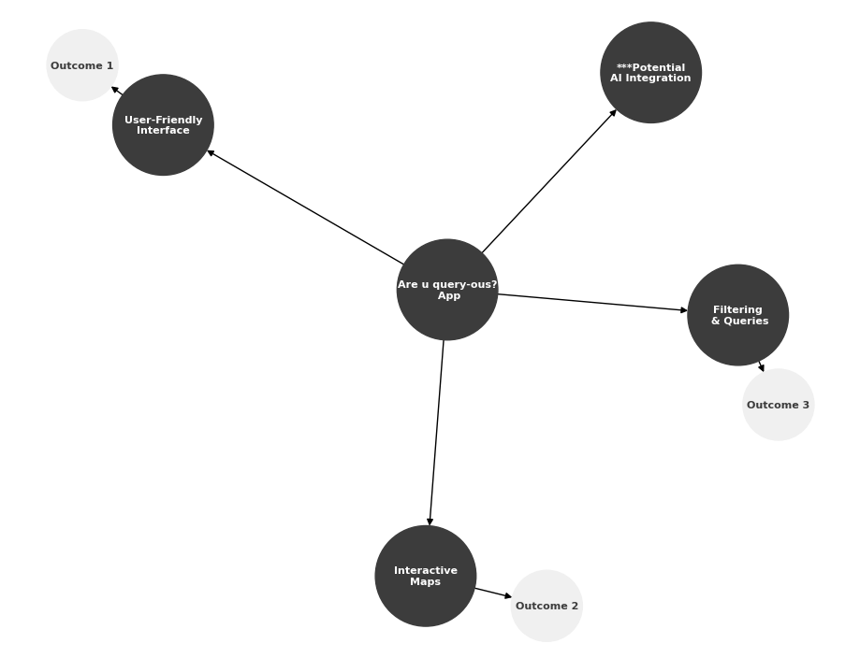

Figure 1 1: Conceptual Representation of Project Summary

1.2 Scope of the Project

This project focuses on developing a web-based platform that allows users to explore and analyze open geospatial data in an intuitive way. The platform will integrate publicly available datasets from Barcelona and Madrid, two cities with well-structured open data portals that provide reliable and detailed information.

The scope includes the following key aspects:

* **Cities Covered:** The platform will use **open data from Barcelona and Madrid**, ensuring access to urban mobility, economic activity, and demographic datasets for meaningful analysis.
* **Data Integration**: The system will collect and process geospatial, economic, and mobility-related data, allowing users to filter and visualize insights interactively.
* **User Interaction**: The web application will feature an interactive map where users can explore regional trends, compare different areas, and extract useful insights without needing technical expertise.
* **Core Functionalities:**
  + *Mapping & Visualization*: Users will view geospatial data overlaid on maps, with filtering options.
  + *Urban & Economic Insights*: The system will present mobility trends, population density, and economic indicators based on selected areas.
  + *Accessibility & Usability*: The interface will be simple and user-friendly, ensuring that both professionals and non-experts can use it effectively.

By **limiting the project scope to Barcelona and Madrid**, the system will leverage well-organized open datasets while **maintaining a manageable level of complexity within the project timeline**. The structured data availability from these cities will support the development, testing, and validation of the platform, ensuring that it meets its intended objectives.

1.2 Justification

Access to open data has grown exponentially, yet many users struggle to transform this data into actionable insights. While businesses and government entities benefit from sophisticated **geo-analytics tools**, individuals and small organizations often lack the resources or expertise to use these datasets effectively. This project is relevant because it seeks to **bridge this gap**, making open data truly accessible and usable for the **general public, students, researchers, and small businesses**.

Moreover, the relevance of geospatial analysis has expanded in fields such as **smart cities, sustainable urban development, and socio-economic research**. By providing an easy-to-use tool, this project supports the broader goal of promoting **data-driven decision-making at all levels of society**.

1.3 Motivation

In the past eight years I have been working and developing my professional career in the field of **data analysis**, so this project aligns with both academic and professional aspirations. The motivation for this project is coming from:

* A personal interest in **making complex data more understandable** for non-experts.
* A desire to provide **access to urban and economic and geomarketing insights** through intuitive visualization for the general public, students, researchers, and small businesses.
* The opportunity **to apply geospatial analytics in a real-world application**.

Additionally, the skills developed through this project, including data processing, backend development, frontend visualization, and user interface design, will be valuable in both academic research and professional settings.

Figure 1 2: Key Motivations for the Project

1.4 Objectives

1.4.1 Main Objective

* To **develop a web-based app that enables users to intuitively explore, filter, and analyze open geospatial data**, making location-based intelligence more accessible to a non-technical audience.

1.4.2 Sub-Objectives

* **Develop an interactive mapping system** that allows users to visualize open data in an intuitive and engaging way.
* **Implement filtering and querying functionalities** to help users refine their search and extract relevant insights.
* **Ensure usability and accessibility** by designing a simple and intuitive user interface.
* **Explore AI-powered search capabilities** to allow natural language queries for easier data retrieval *(optional feature).*
* **Validate the effectiveness of the platform** through user feedback and iterative improvements.

Figure 1 3: Objectives Breakdown

1.5 Hypothesis

Making **geospatial data accessible through an interactive and user-friendly platform** will enable a broader audience to **extract meaningful insights from open data** helping to make **better decision-making and increased public engagement** with geospatial information.

1.6 Sustainability, diversity, and ethical/social challenges

1.6.1 Sustainability

This project promotes sustainability by supporting the efficient **use of open data to improve urban and social planning**. By making geospatial information more accessible, individuals and organizations can make informed decisions about resource allocation, mobility, and land use, reducing unnecessary waste and inefficiencies. Additionally, the project aligns with the United Nations Sustainable Development Goals (SDGs), particularly [Goal 11 (Sustainable Cities and Communities),](https://sdgs.un.org/goals/goal11) by providing insights that encourage responsible urban development. The project has a minimal ecological footprint as it relies on existing digital infrastructure, avoiding additional resource consumption.

1.6.2 Ethical behaviour and social responsibility

The project considers ethical principles by **ensuring data privacy and security**. Since the system processes **publicly available open data**, it does not involve personal or sensitive information. However, the potential risks of misinterpreting data or using insights unethically are acknowledged. To mitigate this, the platform will provide **transparent data sources and disclaimers to ensure users understand the limitations of the information**.

1.6.3 Diversity, gender and human rights

The project is designed to be inclusive and accessible, allowing all individuals, regardless of background, gender, or technical expertise, to explore geospatial data. By offering a simple and user-friendly interface, it ensures that users with limited data experience can engage with geographic insights. Furthermore, **accessibility features will be considered**. The project aligns with the principle of equal access to information, promoting diversity and reducing barriers to data-driven knowledge.

02  
 PLANNING

2.1 Project Planning

A detailed **schedule with milestones** has been defined, ensuring that the development process is structured, manageable, and aligned with the semester timeline.

For a detailed breakdown of the project plan, tasks, and timeline, please refer to the attached **are-you-queryous-planning.xlsx file.** This document provides a structured overview of the planned activities and their expected completion stages.

2.2 Expected Outcome

By the end of the semester, the project will deliver:

* A functional web application where users can **explore and visualize geospatial data** interactively.
* An intuitive filtering system allowing users **to refine results based on key indicators**.
* A structured API serving **open datasets** with a focus on usability and efficiency.
* A research report detailing **the impact of accessible open data visualization**.

This project contributes to the broader goal of **making open data actionable and meaningful** for a **diverse audience**, reinforcing the importance of **geospatial intelligence in everyday decision-making**.

Figure 2 1: Expected Outcome Visual Representation

03  
 METHODS AND RESOURCES

3.1 Approach and Methodology

This project follows a structured development process based on agile principles, allowing for iterative testing and feedback throughout the semester. The key steps include:

3.1.1 Data Collection and Processing

* **Identify and integrate open datasets** (demographic, economic, urban mobility, etc.).
* **Clean and preprocess data** to ensure usability in the application.

3.1.2 Backend Development

* Build a **RESTful API** to serve geospatial data.
* **Store data in a database** optimized for efficient queries.

3.1.3 Frontend Development

* **Design a responsive user interface** with map-based interaction.
* **Implement data visualization tools** for filtering and exploration.

3.1.4 Testing and Refinement

* **Gather feedback** to enhance usability and features.

To manage the development process efficiently, we will use a [**Kanban dashboard in Trello**](https://trello.com/invite/b/67bf7efc26bd6ec81dc82c38/ATTI38f53ad22a39aefe7e4396d30fd5e77bD63960AB/are-you-query-ous). The board will include the following columns:

* **To Do:** List of all planned tasks and ideas.
* **Doing:** Tasks that are ready to be worked on.
* **Deferred:** Tasks that are postponed for later stages.
* **Done**: Completed tasks.

This dashboard will be updated regularly to track progress and **ensure the project stays on schedule**.

Figure 3 1: Process Diagram

3.2 Technology

The project will leverage a modern web technology stack to ensure efficiency, scalability, and a seamless user experience. The core technologies include:

3.2.1 Frontend:

* **React.js** for building a dynamic and interactive user interface.
* **Leaflet.js** for mapping and geospatial visualization.

3.2.2 Backend:

* **FastAPI** to handle API requests and serve processed geospatial data.
* **PostgreSQL/PostGIS** for storing and querying spatial data efficiently.

3.2.3 Data Processing & Integration:

* **Python** and **Pandas** for data preprocessing and transformation.
* **GeoJSON** format to represent geospatial data and serve it dynamically.

3.2.4 Deployment & Hosting:

* **Docker** for containerized development and deployment.
* **GitHub Codespaces** for cloud-based development and collaboration.
* **Vercel**  for frontend deployment and **Fly.io** or **Heroku** for backend deployment.

3.2.5 Potential AI Integration (Optional):

* **NLP Natural Language Processing** for AI-driven queries (future implementation).

These technologies will enable the development of a robust and scalable application that can effectively serve users with varying levels of expertise in data analysis and geospatial exploration.

Figure 3 2: Technology Stack Used

04   
RESULTS

*This section will be further developed in future Continuous Assessment Tests (CATs) and project iterations. Additional details, refinements, and validations will be incorporated as the project progresses.*

05   
CONCLUSIONS AND FUTURE WORK

*This section will be further developed in future Continuous Assessment Tests (CATs) and project iterations. Additional details, refinements, and validations will be incorporated as the project progresses.*

06  
 GLOSSARY

*This section will be further developed in future Continuous Assessment Tests (CATs) and project iterations. Additional details, refinements, and validations will be incorporated as the project progresses.*

07  
 BIBLIOGRAPHY

*This section will be further developed in future Continuous Assessment Tests (CATs) and project iterations. Additional details, refinements, and validations will be incorporated as the project progresses.*

08  
 APPENDICES

*This section will be further developed in future Continuous Assessment Tests (CATs) and project iterations. Additional details, refinements, and validations will be incorporated as the project progresses.*